**Agri Shop**



**Project ID:**

**Session: BSCS Fall 2020 to 2024**

**Project Advisor: Namra Tahir**

**Submitted By**

|  |  |
| --- | --- |
| Zain ul abideen | 70110969 |
| Khizar Ahmad | 70112282 |
|  |  |

Department of Computer Science & IT

The University of Lahore

Lahore, Pakistan

## *Declaration*

We have read the project guidelines and we understand the meaning of academic dishonesty, in particular plagiarism and collusion. We hereby declare that the work we submitted for our final year project, entitled **AGRI SHOP** is original work and has not been printed, published or submitted before as final year project, research work, publication or any other documentation.

## 

**Group Member 1**

**Name:**

**SAP No:**

**Signature: …………………………**

**Group Member 2**

**Name:**

**SAP No:**

**Signature: …………………………**

## *Statement of Submission*

This is to certify that **Zain Ul Abideen** Roll No. **70110969** and **Khizar Ahmad** Roll No. **70112282** have successfully submitted the final project named as: **Agri Shop**, at Computer Science & IT Department, The University of Lahore, Lahore Pakistan, to fulfill the partial requirement of the degree of **BS in Computer Science**.

**Supervisor Name: ………………………**

**Signature: …………………………**

**Date: ………………………**

## *Dedication*

This project is dedicated to Allah, whose guidance and blessings have made everything possible; to our beloved father and mother, whose unwavering support and love have been our foundation; to my wife, whose constant support and encouragement have been my strength; and to our esteemed supervisor, whose mentorship has driven us to achieve our best.

## *Abstract*

The Agri Shop Web Application is designed to tackle challenges within the agricultural supply chain by offering farmers a direct platform to sell their products to consumers. By integrating Natural Language Processing (NLP) technologies, the application enhances accessibility for farmers who may be unable to read or write, thereby broadening their market reach and enabling fairer pricing. The platform aims to streamline the process from farm to consumer, reduce delays, and improve product quality. Additionally, it supports secure online payments, offers a user-friendly interface, and includes features like text-to-speech conversion, language translation, and bidding systems. The application’s revenue model includes transaction fees, premium memberships, and targeted advertisements. It fosters community trust through user reviews, comments, and ratings and plans to generate further engagement through strategic partnerships with agricultural influencers. The Software Requirement Specification outlines the purpose, audience, scope, and functionalities such as user authentication, inventory management, order processing, and customer support. Key considerations include efficient memory management, compliance with regulatory policies, and technology assumptions like scalability and data encryption. Core features are prioritized for the initial release, with future iterations planned based on stakeholder feedback and market demands.

***Area of the Project***

Web Application, Natural Language Processing

***Technologies used***

HTML, CSS, JavaScript, React.js, MySQL, python etc.

## List of Figures

Figure 1 Use case Diagram profile 46

Figure 2 Use case Diagram View Profile 47

*Figure 3 Use case Diagram update profile* 48

Figure 4 Use case Diagram delete profile 50

Figure 5 Use case Diagram Account login 52

Figure 6 Use case Diagram Create product listing 54

Figure 7 Use case Diagram update product listing 56

Figure 8 Use case Diagram Delete product listing 58

Figure 9 Use case Diagram bidding function 60

Figure 10 Use case Diagram Add to cart 62

Figure 11 Use case Diagram voice narrator 63

Figure 12 Use case Diagram online payment 65

Figure 13 Use case Diagram user registration management 67

Figure 14 Use case Diagram inventory management 69

Figure 15 Use case Diagram order processing 71

Figure 16 Use case Diagram refund processing 73

Figure 17 Use case Diagram user authentication 75

Figure 18 Use case Diagram discount and coupons 77

Figure 19 Use case Diagram customer support 78

Figure 20 Architecture Diagram 79

Figure 21 ERD 80

Figure 22 Level 0 Data Flow Diagram 81

Figure 23 Level 1 Data Flow Diagram 81

Figure 24 Class Diagram 82

Figure 25 Activity Diagram Create Account 83

Figure 26 Activity Diagram login account 83

Figure 27 Activity Diagram Edit Profile 84

Figure 28 Activity Diagram customer details 84

Figure 29 Activity Diagram Search product 85

Figure 30 Activity Diagram text to speech 85

Figure 31 Activity Diagram Bidding account 86

Figure 32 Activity Diagram Inventory 86

Figure 33 Activity Diagram payment gateway 87

Figure 34 Sequence Diagram Create Account 88

Figure 35 Sequence Diagram Login Accoun 88

Figure 36 Sequence Diagram Search product 89

Figure 37 Sequence Diagram Inventory management 89

Figure 38 Sequence Diagram Customer details 90

Figure 39 Sequence Diagram payment gateway 90

Figure 40 Sequence Diagram Bidding system 91

Figure 41 Sequence Diagram Text to Speech 91

Figure 42 Aggregated Sequence Diagram 92

Figure 43 Collaboration Diagram 93

Figure 44 State Transition Diagram 94

Figure 45 Component Diagram 95

Figure 46 Deployment Diagram 96

Figure 47 Signup Page 97

Figure 48 Login page 98

Figure 49 Home page 99

Figure 50 Product listing 99

Figure 51 Product page 100

Figure 52 footer 100

## List of Tables

Table 2.1 Create Profile 20

Table 2.2 View profile 21

Table 2.3 Update Profile 22

Table 2.4 Delete profile 23

Table 2.5 Account login 24

Table 2.6 Create Product Listing 25

Table 2.7 Update Product Listing 26

Table 2.8 Delete product listing 27

Table 2.9 Bidding function 28

Table 2.10 Add to Cart 29

Table 2.11 Voice Narrator 30

Table 2.12 online payment 31

Table 2.13 User Registration Management 32

Table 2.14 Inventory management 33

Table 2.15 order processing 34

Table 2.16 refund processing 35

Table 2.17 user authentication 36

Table 2.18 discounts and coupons 37

Table 2.19 Customer Support **Error! Bookmark not defined.**

**Table of Content**

*Declaration* i

*Statement of Submission* ii

*Dedication* iii

*Abstract* iv

List of Figures vi

List of Tables viii

Chapter 1: Introduction to the Problem 12

1.1 Introduction 12

1.2 Purpose 12

1.3 Objective 12

1.4 Existing Solution 13

1.5 Proposed Solution 14

Chapter 2: Software Requirement Specification 16

2.1 Introduction 16

2.1.1 Purpose 16

2.1.2 Scope 16

2.2 Overall description 17

2.2.1 Product perspective 17

2.2.2 Product functions 20

2.2.3 User characteristics 39

2.2.4 Constraints 39

2.2.5 Assumptions and dependencies 42

2.2.5 Apportioning of requirements 43

2.3 Specific requirements 44

2.3.1 Functional Requirement 44

2.3.2 Non-functional Requirements 44

Chapter 3: Use Case Analysis 46

3.1 Create Profile: 46

3.2 View Profile: 47

3.3 Update Profile: 48

3.4 Delete profile: 49

3.5 Account Login: 51

3.6 Create Product linsting: 53

3.7 Update product list: 55

3.8 Delete Product Listing: 57

3.9 Bidding Function: 59

3.10 Add to cart: 61

3.11 Voice narrator: 63

3.12 Online payment: 64

3.13 User Registration Management: 66

3.14 Inventory management: 68

3.15 Order processing: 70

3.16 Refund Processing: 72

3.17 User authentication: 74

3.18 Discounts and Coupons: 76

3.19 Customer support: 78

Chapter 4: Design 79

4.1 Architecture Diagram 79

4.2 ERD with data dictionary 80

4.3 Data Flow diagram 81

4.4 Class Diagram 82

4.5 Activity Diagram 83

4.6 Sequence Diagram 88

4.7 Collaboration Diagram 93

4.8 State Transition Diagram 94

4.9 Component Diagram 95

4.10 Deployment Diagram 96

Chapter 5: User Manual 97

Signup Page 97

Login Page 98

Home Page 99

Product Listing 99

Product Page: 100

Footer: 100

References 101

# Chapter 1: Introduction to the Problem

## 1.1 Introduction

In Pakistan farmers face hurdles such as limited market access, reliance on intermediaries, and a lack of a centralized marketplace. The Agri Shop Web Application aims to address the existing (add before) challenges in the agricultural supply chain by providing a direct platform for farmers to sell their products to consumers. This project seeks to bridge these gaps, empowering farmers to reach a wider consumer base, ensuring fairer pricing, and encouraging a more transparent and efficient agricultural trade ecosystem. Additionally, this web application aims to enhance the overall connectivity and accessibility within the agricultural community, thereby promoting sustainable and direct farmer-to-consumer transactions in an interactive way.

## 1.2 Purpose

The purpose of the Agri Shop Web Application is to address the existing challenges within the agricultural supply chain by providing a direct and efficient platform for farmers to sell their products to consumers. This application is intended to help farmers overcome obstacles such as limited market access, reliance on intermediaries, and the absence of a centralized marketplace. By doing so, it aims to empower farmers to reach a wider consumer base, enable fairer pricing, and foster a more transparent and efficient agricultural trade ecosystem, thus promoting sustainable and direct farmer-to-consumer transactions. Additionally, the application employs Natural Language Processing (NLP) technologies to assist farmers who are unable to read or write. For example, it features a text-to-speech converter and a language translation tool that can transform English text into a local language that is spoken by the farmers, enhancing accessibility and ease of use.

##### 

## 1.3 Objective

* Provide farmers with a platform to directly sell their products to consumers, bypassing intermediaries.
* Expand the market reach for farmers, enabling access to urban and possibly international markets.
* Establish a more transparent pricing mechanism where farmers can get fair prices directly from consumers without the interference of middlemen.
* Streamline the process from farm to consumer to reduce delays, cut costs, and enhance the quality of the end product reaching the consumer.
* Utilize NLP to assist those who cannot read or write by providing text-to-speech conversion and translation into local languages.
* Develop a user-friendly interface that supports secure online payment systems and an option for partial payments through installment plans.
* Generate revenue through transaction fees, premium memberships, and targeted advertisements within the app.
* Incorporate features like user reviews, comments, and ratings to encourage community trust and encourage informed purchasing decisions.
* Engage in strategic partnerships with agricultural influencers and organizations to broaden the customer base and enhance credibility.

## **1.4 Existing** Solution

**Khushaal Watan:**

Khushaal Watan is a free Android app designed for farmers to connect with other stakeholders in the farming community. It offers a plethora of localized agricultural content, accurate weather updates, and the ability to connect with agricultural and livestock experts. The app also provides health insurance for farmers and their families, localized mandi rates, and contact details of nearby agricultural shops and retailers.

**Strengths:**

It offers localized agricultural content and weather updates, which are tailored for specific regions, potentially more beneficial for local farmers.

Farmers can connect with agricultural and livestock experts, which is valuable for gaining tailored advice and support. It provides health insurance and contact details for nearby agricultural shops and retailers, enhancing the overall welfare of farmers and their access to resources.

**Weaknesses:**

It does not mention interactive features such as user input forms or real-time communications, which may limit user engagement compared to your web application.

Its Lack a bidding system and online payment options which are crucial for modern e-commerce and ensuring optimal prices. It does not provide language translation or text-to-speech features for broader accessibility.

**Kissan Bazaar:**

Kissan Bazaar is an online market place where a farmer can buy and sell agriculture items. The app includes separate sections for fruit, vegetable, poultry, and livestock. It provides an e-commerce facility to the farmer making it easy for the rural farmer to get access to the market directly through his smartphone.

**Strengths:**

It directly targets the need for an online marketplace which is excellent for rural farmers to access broader markets. It includes separate sections for various agricultural categories, potentially making it easier for users to navigate and find specific items.

**Weaknesses:**

In this no mention of interactive web views or data visualizations that might enhance user interaction.

It lacks advanced features like bidding systems, language translation, text-to-speech, and comprehensive user reviews which could limit user experience and accessibility. It does not specify if there are flexible payment options like installment plans, which can be a limitation for buyers with financial constraints.

**Bakhabar Kissan:**

Jazz Bakhabar Kissan is a dedicated app that helps farmers to increase their crop yield with updated information and technology. The information provided by this app covers everything from soil preparation to post-harvest, along with livestock and weather updates with audio, video and pictorial presentations. This app indicates how private organizations such as Jazz can contribute to revolutionizing the concept of agriculture in Pakistan.

**Strengths:**

It provides extensive agricultural information from soil preparation to post-harvest, which can significantly help in increasing crop yields.

It utilizes audio, video, and pictorial presentations which can enhance understanding and user engagement.

**Weaknesses:**

It does not provide a platform for buying or selling goods directly or a bidding system which may limit its functionality as a commercial tool. It lacks online payment facilities and user review systems, which are important for building trust and ease of transactions in e-commerce environments. No mention of multiple language support or text-to-speech functionalities for accessibility purposes.

## 1.5 Proposed Solution

The Agri Shop app aims to revolutionize user engagement by employing targeted digital marketing, influencer collaborations, and partnerships with agricultural organizations. These strategies are geared towards fostering active participation and increasing platform awareness. Additionally, it seeks to reduce reliance on third-party services for critical functions like payment processing and delivery, enhancing control and minimizing disruptions. Data privacy is a top priority, addressing concerns about breaches and earning the trust of the agricultural community. By streamlining the supply chain and implementing stringent fraud prevention measures, the app promises a secure trading environment. Setting itself apart from competitors, the Agri Shop Web Application facilitates direct transactions between farmers and consumers, offering a comprehensive solution. It integrates Natural Language Processing (NLP) technology, providing accessibility features like text-to-speech conversion and translation into local languages. This benefits farmers who may face literacy challenges. Moreover, the app presents a structured revenue generation plan through transaction fees, premium memberships, and advertisement opportunities, ensuring sustainable income streams while adding value to users and advertisers alike.

### 

# **Chapter 2:** Software Requirement Specification

## 2.1 Introduction

## Purpose

The Software Requirements Specifications (SRS) document serves to provide a comprehensive understanding of the requirements for developing the Agri Shop Web Application. Its primary purpose is to offer guidance to stakeholders involved in the project, including the development team, project managers, quality assurance personnel, and other relevant parties. The SRS delineates the functional and non-functional requirements necessary for the successful development and implementation of the software.

The intended audience for this SRS includes various stakeholders with a vested interest in the project's success. This audience comprises the development team, including software engineers, developers, designers, and testers, who will directly contribute to the creation of the application. Additionally, project managers responsible for overseeing the project's progress, resource allocation, and timeline management, as well as stakeholders such as farmers, consumers, investors, and regulatory bodies, will benefit from the insights provided in the document. Quality assurance personnel tasked with testing and ensuring the quality and reliability of the software are also part of the intended audience.

## Scope

The software product to be produced by this project is the Agri Shop Web Application. This application aims to revolutionize the agricultural supply chain by providing a platform for farmers to directly list and sell their products to consumers. It will enable consumers to search for and purchase agricultural products from farmers, facilitating secure online payment processing for transactions. Additionally, the application will support language translation and accessibility features to cater to users with literacy challenges. It will incorporate features such as user reviews, comments, and ratings to foster trust and informed purchasing decisions. However, it will not engage in physical delivery or logistics management of agricultural products, provide financial or legal advice to users, or guarantee the success of individual transactions between farmers and consumers. The application's scope aligns with the objectives and goals defined in higher-level specifications, ensuring consistency across the project's documentation and objectives.

* + 1. **Definitions, acronyms, and abbreviations**

|  |  |
| --- | --- |
| Term | Definition |
| Agricultural  Supply Chain | The series of interconnected stages involved in producing, processing,  And distributing agricultural products, from farm to consumer. |
| Intermediaries | Middlemen or third-party entities involved in the distribution and sale of agricultural products, often acting as brokers between farmers and  Consumers. |
| Centralized  Marketplace | A single platform or location where buyers and sellers can interact and  conduct transactions without the need for intermediaries. |
| Natural Language  Processing (NLP) | A branch of artificial intelligence focused on enabling computers to  Understand, interpret, and generate human language. |
| Text-to-Speech (TTS) Conversion | The capability of converting written text into spoken language by synthesizing human-like speech output, facilitating accessibility for  users who may have difficulty reading written content. |
| User Interface  (UI) | The visual elements and interactive features of a software application  through which users interact with the system. |
| Transaction Fees | Charges imposed on users for each transaction conducted through the Agri Shop Web Application, contributing to the platform's revenue  generation. |

|  |  |
| --- | --- |
| Acronyms | Abbreviations |
| NLP | Natural language processing |
| TTS | Text To Speech |

## Overall description

## 2.2.1 Product perspective

The product perspective of the Agri Shop Web Application is with other related products and systems. It is crucial to understand how our product interacts with its environment and interfaces with various components. If the Agri Shop Web Application is independent and self-contained, it will be explicitly stated here. Additionally, a block diagram illustrating the major components of the system, their interconnections, and external interfaces can provide valuable insights.

* **System interfaces**

The Agri Shop Web Application's interface is user-friendly for farmers and buyers alike, allowing for secure sign-ups and quick access to updates via a simple dashboard.

Farmers can effortlessly list their products, while buyers can swiftly find what they need through intuitive search features. The platform facilitates smooth transaction management and fosters easy communication between users. Moreover, its compatibility across various devices ensures seamless accessibility for all users. Overall, the interface is designed with simplicity in mind, prioritizing ease of use and efficiency for enhancing the agricultural trading experience.

* **User interfaces**

The user interface of the Agri Shop Web Application is like a friendly guide for farmers and buyers. It helps them easily navigate the app and find what they're looking for. Farmers can add their products with pictures and descriptions, while buyers can search for items they want to purchase. The app also makes it simple for users to manage their transactions and communicate with each other. It works well on phones, tablets, and computers, so everyone can use it easily. Overall, the interface is designed to be straightforward and helpful, making trading in agriculture more accessible for everyone involved.

* **Hardware interfaces**

The hardware interface of the Agri Shop Web Application connects the software to devices like computers, smartphones, and tablets. It ensures that the app runs smoothly and efficiently on different devices. This interface allows users to interact with the app using touchscreens, keyboards, and other input methods. It also enables features like taking pictures of products using device cameras. The hardware interface ensures that the app's functions, such as processing payments and displaying images, work correctly. It's like a bridge that lets the app communicate with the physical devices it's used on. Overall, the hardware interface makes sure the app is compatible with various devices and easy to use for everyone.

* **Software interfaces**

The software interface of the Agri Shop Web Application is like a translator between the user and the app's functions. It's what allows users to interact with the app and access its features. This interface includes buttons, menus, and screens that users see and interact with. It makes it easy for farmers to list their products and for buyers to search for items they want to purchase. The software interface also manages tasks like processing payments and sending notifications to users. It's designed to be user- friendly, so everyone can use the app without any confusion. Overall, the software interface ensures a smooth and enjoyable experience for users interacting with the app.

* **Communications interfaces**

The communication interface of the Agri Shop Web Application acts like a messenger between users. It allows farmers and buyers to talk to each other easily. This interface includes features like messaging and comments, so users can ask questions or share information. It helps build trust and understanding between users. The communication interface also lets users leave reviews and ratings, so others know about their experiences. It's like a virtual meeting place where users can connect and collaborate. Overall, the communication interface makes it simple for users to communicate and engage with each other within the app.

Comment: This is not about communication. Specify the communication b/w parts of the system.

* **Memory**

The memory of the Agri Shop Web Application stores important information needed for the app to function. Primary memory, like RAM, holds data temporarily while the app is running, allowing for quick access to frequently used information. However, primary memory has limits, so too much data can slow down the app. Secondary memory, such as hard drives or SSDs, stores data for longer periods, like user profiles or product listings. While secondary memory has more storage space, accessing data from it is slower compared to primary memory. It's important to manage memory efficiently to ensure the app runs smoothly and doesn't become sluggish. Overall, balancing primary and secondary memory usage is crucial for optimizing app performance and user experience.

Comment: Isko change krna hai ismy jo baat ho rahi hai kay ram use ni hogi etc. isko gpt pay daal kay website kay mutabiq krna

* **Operations**

Operations in the Agri Shop Web Application involve regular tasks like user management, product listing, and transaction processing. These normal operations ensure the smooth functioning of the platform on a daily basis. Additionally, special operations such as backup and recovery are crucial for safeguarding data and restoring the system in case of emergencies. Backup operations involve regularly saving data to secure storage to prevent loss in case of system failure. Recovery operations help restore the application to a stable state after encountering issues, ensuring minimal disruption to users. Overall, both normal and special operations are essential for maintaining the reliability and continuity of the Agri Shop Web Application.

Comment: Don’t define. Explain your plan to incorporate this

* **Site adaptation requirements**

Site adaptation requirements for the Agri Shop Web Application involve customizing data and initialization sequences to suit specific locations, missions, or operational modes. This includes tailoring the application to accommodate regional preferences, languages, and currencies. Additionally, site-specific requirements may involve integrating local regulations or market dynamics into the application's functionality. Initialization sequences need to be adjusted to ensure seamless deployment and operation of the application in different environments. These adaptations are essential for optimizing user experience and ensuring the application's effectiveness in diverse contexts. Overall, site adaptation requirements aim to make the Agri Shop Web Application relevant, accessible, and functional across various sites, missions, and operational modes.

## 2.2.2 Product functions

|  |  |  |  |  |
| --- | --- | --- | --- | --- |
| ID: | FR_01 | | | |
| Name: | Create Profile | | | |
| Description | Input | Output | Requirements | Basic Work Flow |
| Enter details to create account | Name, Email, Password etc. | Profile created. | Internet Connectivity required. | Enter correct information and click submit button  System save the record in database. |

Table 2.1 Create Profile

|  |  |  |  |  |
| --- | --- | --- | --- | --- |
| ID: | FR_02 | | | |
| Name: | View Profile | | | |
| Description | Input | Output | Requirements | Basic Work Flow |
| Enter details to create account | User ID (retrieved from session after created) | Display of account details (Name, Email, and Phone Number. | Internet Connectivity required , user must be logged in. | User navigates to the "View Account" page. System retrieves the user's details from the database using the User ID. System displays the user's account details  on the screen. |

Table 2.2 View profile

|  |  |  |  |  |
| --- | --- | --- | --- | --- |
| ID: | FR_03 | | | |
| Name: | Update Profile | | | |
| Description | Input | Output | Requirements | Basic Work Flow |
| Enter details to create account | Name, Email,  Phone Number, Password | Profile update confirmation message. | Internet Connectivity required. | User navigates to the "Update Account" page. User enters new details. User clicks the "Submit" button. System validates the new input. System updates the user record in the database. User receives an "Account updated" confirmation  Message. |

Table 2.3 Update Profile

password should be separate module means iska aik or table banay ga password update ka

|  |  |  |  |  |
| --- | --- | --- | --- | --- |
| ID: | FR_04 | | | |
| Name: | Delete Profile | | | |
| Description | Input | Output | Requirements | Basic Work Flow |
| Enter details to create account | Name, Email,  Phone Number, Password | Profile deletion confirmation message. | Internet Connectivity required, user must be logged in. | User navigates to the "Delete Account" page. User clicks the "Delete Account" button. System asks for confirmation. User confirms account  deletion. System deletes the user record from the database. User receives an "Account deleted" confirmation  message. |

Table 2.4 Delete profile

|  |  |  |  |  |
| --- | --- | --- | --- | --- |
| ID: | FR_05 | | | |
| Name: | Account login | | | |
| Description | Input | Output | Requirements | Basic Work Flow |
| Enter details to create account | Email, Password | Login success or failure message. | Internet Connectivity required. | User navigates to the "Login" page. User enters their Email and Password. User clicks the "Login" button. System validates the email and password. If valid, system starts a user session and redirects to the  dashboard. User receives a "Login successful" message or  an error message. |

Table 2.5 Account login

|  |  |  |  |  |
| --- | --- | --- | --- | --- |
| ID: | FR_06 | | | |
| Name: | Create Product Listing | | | |
| Description | Input | Output | Requirements | Basic Work Flow |
| Enter details to create account | Product Name, Category, Price, Quantity, Description, Images. | Product listing created confirmation message. | User must be logged in, Internet connectivity. | Farmer navigates to the "Create Product Listing" page. Farmer enters product details and uploads images. Farmer clicks the "Submit" button. System validates the input. System saves the product listing in the database. Farmer receives a "Product listing created" confirmation message. |

Table 2.6 Create Product Listing

|  |  |  |  |  |
| --- | --- | --- | --- | --- |
| ID: | FR_07 | | | |
| Name: | Update Product Listing | | | |
| Description | Input | Output | Requirements | Basic Work Flow |
| Enter details to create account | Product ID, updated Product Name, Category, Price, Quantity, Description, Images. | Product listing updated confirmation message. | User must be logged in, Internet connectivity. | Farmer navigates to the "Update Product Listing" page. Farmer selects the product to update. Farmer enters updated product details and uploads new images. Farmer clicks the "Submit" button. System validates the new input. System updates the product listing in the database. Farmer receives a "Product listing updated" confirmation message. |

Table 2.7 Update Product Listing

|  |  |  |  |  |
| --- | --- | --- | --- | --- |
| ID: | FR_08 | | | |
| Name: | Delete Product Listing | | | |
| Description | Input | Output | Requirements | Basic Work Flow |
| Enter details to create account | Product ID | Product listing deletion confirmation message. | User must be logged in, Internet connectivity. | Farmer navigates to the "Delete Product Listing" page. Farmer selects the product to delete. Farmer clicks the "Delete" button. System asks for confirmation. Farmer confirms the deletion. System deletes the product listing from the database. Farmer receives a "Product listing deleted"  confirmation message. |

Table 2.8 Delete product listing

|  |  |  |  |  |
| --- | --- | --- | --- | --- |
| ID: | FR_09 | | | |
| Name: | Bidding function | | | |
| Description | Input | Output | Requirements | Basic Work Flow |
| Allows users to | Product ID, Bid | Confirmation | User must be | User navigates to the product listing page that supports bidding. User views the current highest bid and decides on a bid amount.  User enters the bid amount and clicks the 'Place Bid' button.  The system checks if the bid amount is higher than the current highest bid.  If valid, the system records the bid and updates the highest bid information.  Display confirmation message to the user and  update bid history for the product. |
| place bids on | Amount | message | logged in, |
| agricultural |  | indicating | Internet |
| products listed |  | the bid has | connectivity. |
| for auction, |  | been placed, |  |
| enabling |  | updated bid |  |
| competitive |  | history. |  |
| pricing and fair |  |  |  |
| market value. |  |  |  |

Table 2.9 Bidding function

|  |  |  |  |  |  |
| --- | --- | --- | --- | --- | --- |
| ID: | FR_10 | | | | |
| Name: | Add to Cart | | | | |
| Description | Input | | Output | Requirements | Basic Work Flow |
| Allows users to | Product | ID, | Confirmation | User must be | User navigates to the product listing page.  User selects a product and specifies the quantity.  User clicks the 'Add to Cart' button.  The system checks the availability of the product. Adds it to the user's shopping cart.  Display confirmation message to the user. |
| add products to | Quantity. |  | message | logged in, |
| their virtual |  |  | indicating | Internet |
| shopping cart |  |  | the product | connectivity. |
| for later |  |  | has been |  |
| purchase. |  |  | added to the |  |
|  |  |  | cart. |  |

Table 2.10 Add to Cart

|  |  |  |  |  |
| --- | --- | --- | --- | --- |
| ID: | FR_11 | | | |
| Name: | Voice Narrator | | | |
| Description | Input | Output | Requirements | Basic Work Flow |
| Provides voice | Text displayed on | Audio | User must be | Users navigate to a page with text (e.g., registration, product listing).  The system detects the text to be narrated.  Users click the 'Voice Narrator' button.  The system converts the text to speech.  Audio narration is played, reading out the  text on the screen. |
| narration for | the screen. | narration of | logged in, |
| key |  | the text. | Internet |
| functionalities |  |  | connectivity, |
| to assist users |  |  | Device with |
| who are unable |  |  | audio output |
| to read or write. |  |  | capability. |

Table 2.11 Voice Narrator

|  |  |  |  |  |
| --- | --- | --- | --- | --- |
| ID: | FR_12 | | | |
| Name: | Online Payment | | | |
| Description | Input | Output | Requirements | Basic Work Flow |
| Allows users to | Payment Method, | Confirmation | Internet | User proceeds to checkout after adding products to the cart.  User selects a preferred payment method (e.g., credit card, debit card, digital wallet).  User enters required payment details (e.g., card number, expiration date, CVV). User clicks the 'Pay Now' button.  The system processes the payment through a secure payment gateway.  Display confirmation message to the user and update the order status. |
| make secure | Card Details or | message | connectivity, |
| online | Digital Wallet | indicating | Secure |
| payments for | Information. | successful | payment |
| products |  | payment, | gateway |
| purchased on |  | updated | integration. |
| the Agri Shop |  | order status. |  |
| Web |  |  |  |
| Application. |  |  |  |

Table 2.12 online payment

|  |  |  |  |  |
| --- | --- | --- | --- | --- |
| ID: | FR_13 | | | |
| Name: | User Registration Management | | | |
| Description | Input | Output | Requirements | Basic Work Flow |
| Allows admins to approve or reject user registrations. | User registration details. | Confirmation of registration approval or rejection. | Admin privileges, Internet connectivity. | Admin accesses the user registration management section.  Admin reviews  pending user registration details.  Admin approves or rejects the user registration.  System updates user status and notifies user via email.  Display confirmation message to the admin. |

Table 2.13 User Registration Management

|  |  |  |  |  |
| --- | --- | --- | --- | --- |
| ID: | FR_14 | | | |
| Name: | Inventory Management | | | |
| Description | Input | Output | Requirements | Basic Work Flow |
| Enables admins to monitor stock levels, update inventory, and manage low stock alerts. | Product ID, Stock quantity. | Updated inventory levels, Low stock alerts. | Admin privileges, Internet connectivity. | Admin navigates to the inventory management section.  Admin enters or updates stock quantities for products. System updates the inventory levels in the database.  System generates low stock alerts for products below threshold levels.  Display confirmation message to the admin. |

Table 2.14 Inventory management

|  |  |  |  |  |
| --- | --- | --- | --- | --- |
| ID: | FR_15 | | | |
| Name: | Order Processing and Tracking | | | |
| Description | Input | Output | Requirements | Basic Work Flow |
| Allows admins to view, process, update order statuses (pending, shipped, delivered, etc.), and provide tracking information to customers. | Order ID, Updated Status, Tracking Number. | Updated order status, Tracking information, Confirmation message. | Admin privileges, Internet connectivity. | Admin navigates to the order management section.  Admin selects an order to view its details.  Admin updates the order status (e.g., from pending to shipped).  Admin enters the tracking number for the shipped order.  System saves the updated status and tracking information in the database.  Display confirmation message to the admin. Customer views their order details and tracking information through their account. System updates tracking information in real-time as provided by the shipping carrier. Display tracking  updates to the customer. |

Table 2.15 order processing

Isko khatam kar kay yaha private company kay sth contract krna courier kay liye . kay company order dispatch karay gi or courier walay ko wo khud track kry ga.. jo cost hamay apni shipping kay liye ay gi wo ham courier walay ko dain gay

|  |  |  |  |  |
| --- | --- | --- | --- | --- |
| ID: | FR_16 | | | |
| Name: | Refund Processing | | | |
| Description | Input | Output | Requirements | Basic Work Flow |
| Allows admins to handle and process refund requests submitted by customers. | Refund Request ID, Refund Amount. | Confirmation of refund processing. | Admin privileges, Internet connectivity. | Customer submits a refund request through their account.  Admin reviews the refund request in the refund management section.  Admin approves or rejects the refund request.  If approved, admin processes the refund through the appropriate payment gateway.  System updates the transaction and order status to reflect the refund.  Display confirmation message to the customer and admin. |

Table 2.16 refund processing

|  |  |  |  |  |
| --- | --- | --- | --- | --- |
| ID: | FR_17 | | | |
| Name: | User Authentication | | | |
| Description | Input | Output | Requirements | Basic Work Flow |
| Implements strong authentication mechanisms, including two- factor authentication (2FA), to  Ensure secure access to the Agri Shop Web Application. | User credentials (username, password), 2FA code. | Access granted or denied message. | Internet connectivity, Integration with 2FA service provider. | User navigates to the login page.  User enters their username and password.  System verifies the entered credentials.  If credentials are correct, system prompts user to enter a 2FA code sent to their registered device (e.g., phone, email).  User enters the 2FA code.  System verifies the 2FA code.  If the 2FA code is correct, system grants access to the user and redirects them to their dashboard.  If credentials or 2FA code are incorrect, system displays an error message and denies access. |

Table 2.17 user authentication

|  |  |  |  |  |
| --- | --- | --- | --- | --- |
| ID: | FR_18 | | | |
| Name: | Discounts and Coupons | | | |
| Description | Input | Output | Requirements | Basic Work Flow |
| Allows admins | Discount code | Confirmation | Admin | Admin navigates to the |
| to create and | details (code, | of discount | privileges, | marketing and |
| manage | percentage or | code creation | Internet | promotions section. |
| discount codes and promotions for customers. | amount off,  expiration date, usage limits). | or update. | connectivity. | Admin selects the  option to add or edit a discount code.  Admin enters discount |
|  |  |  |  | code details including |
|  |  |  |  | code, percentage or |
|  |  |  |  | amount off, expiration |
|  |  |  |  | date, and usage limits. |
|  |  |  |  | Admin saves the |
|  |  |  |  | discount code |
|  |  |  |  | configuration. |
|  |  |  |  | System updates the |
|  |  |  |  | discount codes in the |
|  |  |  |  | database. |
|  |  |  |  | Display confirmation |
|  |  |  |  | message to the admin. |
|  |  |  |  | Customers can enter |
|  |  |  |  | discount codes during |
|  |  |  |  | checkout to receive the |
|  |  |  |  | specified discount. |

Table 2.18 discounts and coupons

|  |  |  |  |  |
| --- | --- | --- | --- | --- |
| ID: | FR_19 | | | |
| Name: | Customer Support | | | |
| Description | Input | Output | Requirements | Basic Work Flow |
| Provides tools | Support ticket | Confirmation | Admin | Customer submits a |
| for managing | details (customer | of ticket | privileges, | support ticket or |
| customer | name, issue | resolution or | Internet | inquiry through the |
| support tickets and inquiries, as well as creating and managing a knowledge base and FAQs to assist customers. | description), FAQ details (question, answer). | FAQ  creation/update. | connectivity. | help desk section.  Admin accesses the customer support management section to view and manage support tickets.  Admin reviews and responds to support tickets, resolving issues as needed. |
|  |  |  |  | System updates the |
|  |  |  |  | status of the support |
|  |  |  |  | ticket and notifies the |
|  |  |  |  | customer of the |
|  |  |  |  | resolution. |
|  |  |  |  | Admin navigates to |
|  |  |  |  | the knowledge base |
|  |  |  |  | management section |
|  |  |  |  | to add or update |
|  |  |  |  | FAQs. |
|  |  |  |  | Admin enters FAQ |
|  |  |  |  | details including |
|  |  |  |  | question and answer. |
|  |  |  |  | Admin saves the |
|  |  |  |  | FAQ. |
|  |  |  |  | System updates the |
|  |  |  |  | knowledge base with |
|  |  |  |  | the new or updated |
|  |  |  |  | FAQ. |
|  |  |  |  | Customers can access |
|  |  |  |  | the FAQs and |
|  |  |  |  | knowledge base for |
|  |  |  |  | self-service support. |

s

## 2.2.3 User characteristics

The intended users of the Agri Shop Web Application vary widely in terms of educational level, experience, and technical expertise. Farmers, who form a significant portion of the user base, may have varying levels of education from basic literacy to advanced degrees in agriculture. Their experience with technology ranges from minimal to moderate, primarily through basic smartphone use. To accommodate their needs, the application should be intuitive and provide ample guidance.

Consumers, on the other hand, generally have higher educational backgrounds and are familiar with e-commerce platforms. They are comfortable with online transactions and navigating digital interfaces. Therefore, the application should offer advanced search options, secure payment gateways, and a seamless user experience.

Agricultural experts and advisors typically possess specialized degrees and extensive experience in the agricultural sector. They have high technical expertise and use digital tools for research and communication. The application should include features like data analytics and expert forums to meet their needs.

Other stakeholders, such as investors and regulatory bodies, also interact with the application. These users often have higher education qualifications in business, finance, or law and are proficient in using complex software systems. The application should provide detailed reports and secure data access to cater to their requirements. Understanding these diverse user characteristics ensures the Agri Shop Web Application is accessible, user- friendly, and meets the varied needs of its users.

## 2.2.4 Constraints

* **Regulatory Policies**

The application must comply with regulatory frameworks governing agricultural trade, consumer protection, and data privacy. This includes adhering to laws and standards related to online transactions, data handling, and user privacy to ensure legal compliance and user trust.

* **Hardware Limitations**

The performance and capabilities of the hardware used by farmers and consumers, such as smartphones and computers, impose constraints on the application. It must be optimized to function effectively across various devices with varying processing power, memory, and screen sizes.

* **Interfaces to Other Application**

Integration with external systems or applications, such as payment gateways, weather APIs, or government databases, imposes constraints on data exchange protocols and compatibility requirements. The application must seamlessly interact with these interfaces to provide accurate information and smooth transactions.

* **Parallel Operation**

The application's ability to handle multiple concurrent users and transactions, known as parallel operation, imposes constraints on scalability, performance, and resource management. It must efficiently manage server resources and database access to prevent bottlenecks during peak usage periods.

* **Audit and Control Functions**

To ensure accountability and transparency, the application may require audit trails and control functions to track user actions, manage permissions, and enforce security policies. These functions impose constraints on data logging, access control mechanisms, and system monitoring.

* **Reliability and Safety Considerations**

The criticality of agricultural transactions and user data necessitates reliability and safety measures. The application must ensure data integrity, fault tolerance, and disaster recovery capabilities to mitigate risks of system failures or data breaches.

* **Higher-Order Language Requirements**

Depending on the target user base and operational environment, the application may have language requirements for localization and accessibility. Multilingual support and cultural adaptation impose constraints on user interfaces, content translation, and communication protocols.

* **Signal Handshake Protocols**

For seamless communication between different components of the application, signal handshake protocols impose constraints on data synchronization, error handling, and message integrity. Proper protocol implementation ensures reliable data exchange and system interoperability.

* **Criticality of the Application**

Given the application's role in facilitating agricultural transactions and connecting farmers with consumers, its criticality imposes constraints on uptime, response times, and service availability. The application must prioritize reliability and performance to support continuous operations.

* **Safety and Security Considerations**

To protect user data, financial transactions, and sensitive information, the application must adhere to stringent security measures. Constraints include encryption standards, access controls, authentication mechanisms, and vulnerability management to safeguard against cyber threats and unauthorized access.

## 2.2.5 Assumptions and dependencies

* **Operational environment Assumptions**

Assumptions regarding the operational environment include factors such as the availability of stable internet connectivity for users accessing the Agri Shop Web Application. It assumes that users will have access to devices like smartphones or computers capable of running the application smoothly. Additionally, it assumes basic familiarity with using digital platforms among both farmers and consumers, ensuring they can effectively engage with the application's features.

* **External Dependencies**

Dependencies on external systems or services, such as payment gateways, weather APIs for agricultural updates, or government databases for regulatory compliance, are critical. The functionality and performance of the Agri Shop Web Application depend on seamless integration with these external interfaces. Changes or disruptions in these dependencies could impact the application's ability to provide accurate information and conduct transactions securely.

* **Regulatory and Legal Assumptions**

Assumptions related to regulatory and legal compliance involve adherence to laws governing e-commerce, data privacy, and agricultural trade. It assumes that the application will comply with relevant regulations, ensuring user trust and legal operation. Changes in regulatory requirements could necessitate updates to the application's functionalities and data handling practices.

* **Business and Organizational Assumptions**

Business assumptions may include expectations about revenue models, user adoption rates, and partnerships with agricultural stakeholders. For instance, assumptions about generating revenue through transaction fees or advertising within the application influence its design and feature prioritization. Changes in business strategies or market conditions may require adjustments to the application's business logic and operational framework.

* **Technology Assumptions**

Assumptions about technological capabilities, such as the scalability of server infrastructure, the effectiveness of data encryption methods, and the compatibility of software across different devices and operating systems, are also critical. The application assumes that technological solutions implemented during development will effectively support its operational requirements and user demands.

.

## 2.2.5 Apportioning of requirements

**Prioritization of Core Features:**

During initial development phases, core features essential for the application's basic functionality and usability are prioritized. These include functionalities such as user registration, product listing and searching, secure online transactions, and basic communication tools between farmers and consumers. By focusing on these foundational elements, the development team ensures the application's viability and immediate utility to users.

* **Deferred Features:**

Certain features that are deemed non-critical or require more extensive development effort may be postponed to future releases. These could include advanced analytics and reporting capabilities, integration with complex third-party systems, additional language support, or enhanced user customization options. Deferring these features allows the team to concentrate on delivering a robust initial version of the application while planning for incremental improvements and enhancements over time.

* **Stakeholder Feedback and Iterative Development:**

The decision to apportion requirements is influenced by ongoing stakeholder feedback and iterative development practices. Input from farmers, consumers, agricultural experts, and other stakeholders helps prioritize features based on user needs and market demands. Agile methodologies, such as Scrum or Kanban, facilitate adaptive planning and continuous refinement of requirements, enabling the team to respond effectively to changing priorities and emerging opportunities.

* **Roadmap for Future Releases:**

The Apportioning of Requirements section serves as a roadmap for future releases of the Agri Shop Web Application. It outlines a strategic approach to phased feature implementation, balancing immediate user requirements with long-term project goals. By outlining clear timelines and milestones for deferred features, the development team can maintain transparency with stakeholders and manage expectations regarding the evolution of the application.

## 2.3 Specific requirements

This section details the functional and non-functional requirements necessary for the Agri Shop Web Application. These requirements provide a detailed framework for designers to develop a system that meets user expectations and can be rigorously tested to ensure compliance with specified criteria.

## 2.3.1 Functional Requirement

Functional Requirements outline the specific modules and functionalities of the Agri Shop Web Application. These include:

* **User Registration:** Farmers and consumers should be able to create and manage their accounts securely.
* **Product Listing and Search:** Farmers can list agricultural products with descriptions and images, while consumers can search and browse products.
* **Transaction Management:** Facilitate secure online transactions between farmers and consumers, ensuring reliability and data integrity.
* **Communication Tools:** Provide messaging or commenting features to foster interaction and trust between users.
* **Accessibility Features:** Implement Natural Language Processing (NLP) for text-to-speech and language translation to support users with literacy challenges.
* **Revenue Generation:** Include mechanisms for transaction fees, premium memberships, and targeted advertisements to sustain the platform financially.
* **User Feedback:** Enable user reviews, ratings, and comments to enhance transparency and informed decision-making.

## 2.3.2 Non-functional Requirements

Non-functional Requirements specify attributes of the Agri Shop Web Application beyond its specific functionalities. These include:

* **Usability:** Ensure the application is intuitive and easy to navigate for users with varying technical expertise.
* **Reliability:** Maintain high availability and minimize downtime to ensure continuous access to the platform.
* **Performance:** Support concurrent users and handle peak loads efficiently to provide responsive user experiences.
* **Design Constraints:** Adhere to regulatory, legal, and technical standards governing e- commerce and data privacy.
* **Portability:** Ensure compatibility across devices and platforms (e.g., smartphones, tablets, computers) to maximize accessibility.
* **Maintainability:** Facilitate easy updates, maintenance, and scalability of the application to accommodate future enhancements.
* **License Agreement:** Clearly define terms of use and licensing agreements to protect intellectual property and ensure legal compliance.

# Chapter 3: Use Case Analysis

## 3.1 Create Profile:

|  |  |
| --- | --- |
| Use Case ID | FR_01 |
| Use Case Name | Create Profile |
| Description | Allows a user to create a new profile on the Agri Shop web application. |
| Primary Actor | User |
| Secondary Actor | None |
| Pre-Condition | The user must have internet connectivity. |
| Post-Condition | A new profile is created and saved in the database. |
| Basic Flow | The user begins by entering their name, email, password, and other necessary details into the designated fields. After ensuring all information is correct, the user clicks the submit button. The system then validates the provided input and, upon successful validation, saves the user's information in the database. Finally, the system confirms that the profile has been created successfully. |

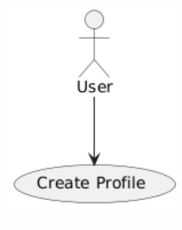

**Isko change krna hai maham logo ki doc dekho is sy pehly aik general overall diagram hai**

Figure 1 Use case Diagram profile

## 3.2 View Profile:

|  |  |
| --- | --- |
| Use Case ID | FR_02 |
| Use Case Name | View Profile |
| Description | Allows a user to view their profile details on the Agri Shop web application. |
| Primary Actor | User |
| Secondary Actor | None |
| Pre-Condition | The user must be logged in and have an internet connection. |
| Post-Condition | The user's profile details are displayed on the screen. |
| Basic Flow | User navigates to the "View Account" page. System retrieves the user's details from the database using the User ID. System displays the user's account details on the screen. |

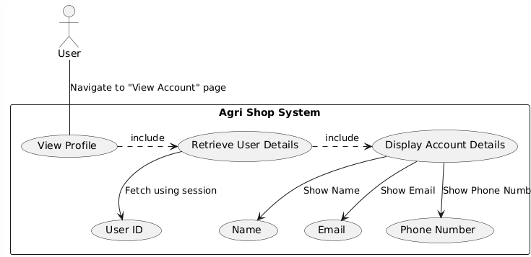

Figure 2 Use case Diagram View Profile

## 3.3 Update Profile:

|  |  |
| --- | --- |
| Use Case ID | FR_03 |
| Use Case Name | Update Profile |
| Description | Allows a user to update their profile details on the Agri Shop mobile application. |
| Primary Actor | User |
| Secondary Actor | None |
| Pre-Condition | The user must be logged in and have an internet connection. |
| Post-Condition | The user's profile is updated, and a confirmation message is displayed. |
| Basic Flow | User navigates to the "Update Account" page. User enters new details. User clicks the "Submit" button. System validates the new input. System updates the user record in the database. User receives an "Account updated" confirmation message. |

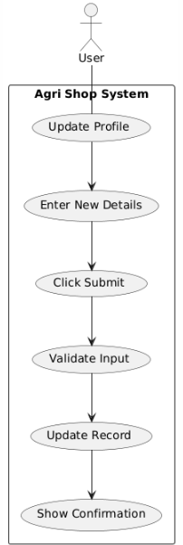

Yaha include or extend wala feature dalna dubara plant uml sy krwa lena

*Figure 3 Use case Diagram update profile*

## 3.4 Delete profile:

|  |  |
| --- | --- |
| Use Case ID | FR_04 |
| Use Case Name | Delete profile |
| Description | Allows a user to delete their profile details on the Agri Shop mobile application. |
| Primary Actor | User |
| Secondary Actor | None |
| Pre-Condition | The user must be logged in and have an internet connection. |
| Post-Condition | The user's profile is deleted, and a confirmation message is displayed. |
| Basic Flow | User navigates to the "Delete Account" page. User clicks the "Delete Account" button. System asks for confirmation. User confirms account deletion. System deletes the user record from the database. User receives an "Account deleted" confirmation message. |

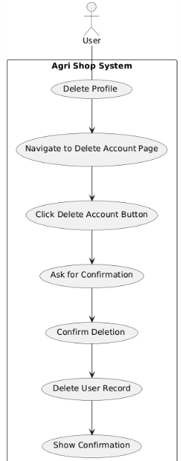

Figure 4 Use case Diagram delete profile

## 3.5 Account Login:

|  |  |
| --- | --- |
| Use Case ID | FR_05 |
| Use Case Name | Account Login |
| Description | Allows a user to log in to the Agri Shop mobile application using their email and password. |
| Primary Actor | User |
| Secondary Actor | None |
| Pre-Condition | The user must have a registered account and an internet connection. |
| Post-Condition | User is logged in, and a success or error message is displayed. |
| Basic Flow | User navigates to the "Login" page. User enters their Email and Password. User clicks the "Login" button. System validates the email and password. If valid, the system starts a user session and redirects to the dashboard. User receives a "Login successful" message or an error message. |

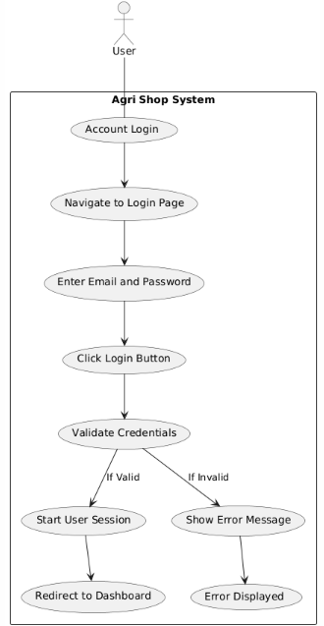

Figure 5 Use case Diagram Account login

## 3.6 Create Product linsting:

|  |  |
| --- | --- |
| Use Case ID | FR_06 |
| Use Case Name | Create Product Listing |
| Description | Allows a farmer to create a new product listing by providing details an  Uploading images. |
| Primary Actor | Farmer |
| Secondary Actor | None |
| Pre-Condition | The farmer must have a registered account and an internet connection. |
| Post-Condition | The product listing is created, and a confirmation message is displayed. |
| Basic Flow | Farmer navigates to the "Create Product Listing" page. Farmer enters product details and uploads images. Farmer clicks the "Submit" button. System validates the input. System saves the product listing in the database. Farmer receives a "Product listing created" confirmation message. |

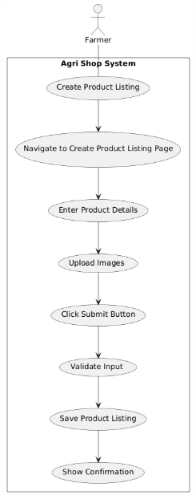

Figure 6 Use case Diagram Create product listing

## 3.7 Update product list:

|  |  |
| --- | --- |
| Use Case ID | FR_07 |
| Use Case Name | Update product listing |
| Description | Allows a farmer to update an existing product listing by providing updated details and uploading new images. |
| Primary Actor | Farmer |
| Secondary Actor | None |
| Pre-Condition | The farmer must have a registered account and an internet connection. |
| Post-Condition | The product listing is updated, and a confirmation message is displayed. |
| Basic Flow | Farmer navigates to the "Update Product Listing" page. Farmer selects the product to update. Farmer enters updated product details and uploads new images. Farmer clicks the "Submit" button. System validates the new input. System updates the product listing in the database. Farmer receives a "Product listing updated" confirmation message. |

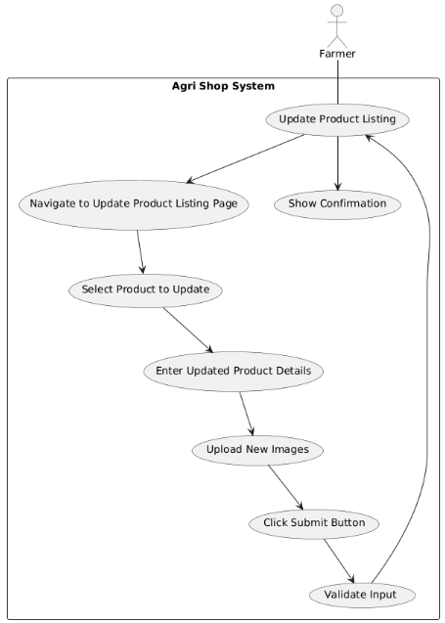

Figure 7 Use case Diagram update product listing

## 3.8 Delete Product Listing:

|  |  |
| --- | --- |
| Use Case ID | FR_08 |
| Use Case Name | Delete Product Listing |
| Description | Allows a farmer to delete an existing product listing from the system. |
| Primary Actor | Farmer |
| Secondary Actor | None |
| Pre-Condition | The farmer must have a registered account and an internet connection. |
| Post-Condition | The product listing is deleted, and a confirmation message is displayed. |
| Basic Flow | Farmer navigates to the "Delete Product Listing" page. Farmer selects the product to delete. Farmer clicks the "Delete" button. System asks for confirmation. Farmer confirms the deletion. System deletes the product listing from the database. Farmer receives a "Product listing deleted" confirmation message. |

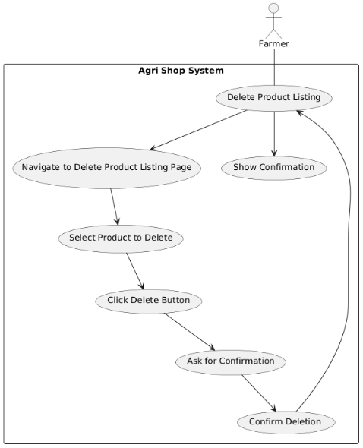

Figure 8 Use case Diagram Delete product listing

## 3.9 Bidding Function:

|  |  |
| --- | --- |
| Use Case ID | FR_09 |
| Use Case Name | Bidding Function |
| Description | Allows users to place bids on agricultural products listed for auction, facilitating competitive pricing and fair market value. |
| Primary Actor | User |
| Secondary Actor | None |
| Pre-Condition | The user must be logged in and have an internet connection. |
| Post-Condition | The bid is placed, and the bid history is updated. |
| Basic Flow | User navigates to the product listing page that supports bidding. User views the current highest bid and decides on a bid amount. User enters the bid amount and clicks the 'Place Bid' button. The system checks if the bid amount is higher than the current highest bid. If valid, the system records the bid and updates the highest bid information. Display confirmation message to the user and update bid history for the product. |

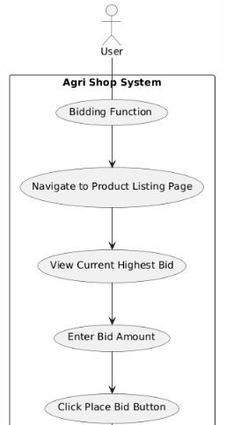

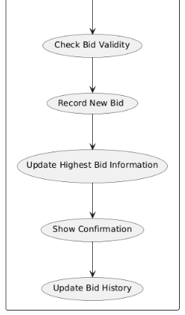

Figure 9 Use case Diagram bidding function

## 3.10 Add to cart:

|  |  |
| --- | --- |
| Use Case ID | FR_10 |
| Use Case Name | Add to cart |
| Description | Allows users to add products to their virtual shopping cart for later purchase |
| Primary Actor | User |
| Secondary Actor | None |
| Input | Product ID, Quantity |
| Output | Confirmation message indicating the product has been added to the cart |
| Basic Flow | User navigates to the product listing page. User selects a product and specifies the quantity. User clicks the 'Add to Cart' button. The system checks the availability of the product. Adds it to the user's shopping cart. Display confirmation message to the user. |

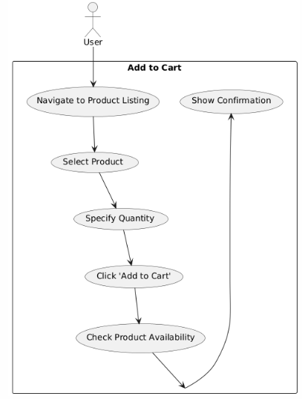

Figure 10 Use case Diagram Add to cart

## 3.11 Voice narrator:

|  |  |
| --- | --- |
| Use Case ID | FR_11 |
| Use Case Name | Voice narrator |
| Description | Provides voice narration for key functionalities to assist users who are unable to read or write. |
| Primary Actor | User |
| Secondary Actor | None |
| Input | Text displayed on the screen. |
| Output | Audio narration of the text. |
| Basic Flow | Users navigate to a page with text (e.g., registration, product listing). The system detects the text to be narrated. Users click the 'Voice Narrator' button. The system converts the text to speech. Audio narration is played, reading out the text on the screen. |

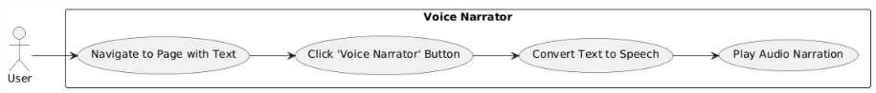

Figure 11 Use case Diagram voice narrator

## 3.12 Online payment:

|  |  |
| --- | --- |
| Use Case ID | FR_12 |
| Use Case Name | Online Payment |
| Description | Allows users to make secure online payments for products purchased on the Agri Shop Web Application |
| Primary Actor | User |
| Secondary Actor | None |
| Input | Payment Method, Card Details or Digital Wallet Information. |
| Output | Confirmation message indicating successful payment, updated order status. |
| Basic Flow | User proceeds to checkout after adding products to the cart. User selects a preferred payment method (e.g., credit card, debit card, digital wallet). User enters required payment details (e.g., card number, expiration date, CVV). User clicks the 'Pay Now' button. The system processes the payment through a secure payment gateway. Display confirmation message to the user and update the order status. |

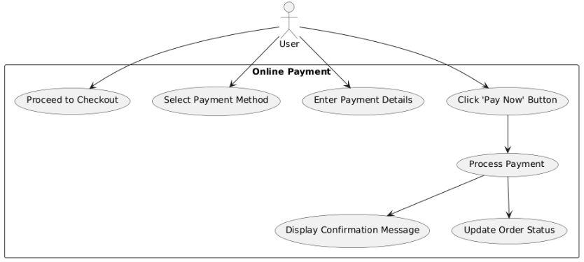

Figure 12 Use case Diagram online payment

## 3.13 User Registration Management:

|  |  |
| --- | --- |
| Use Case ID | FR_13 |
| Use Case Name | User Registration Management |
| Description | Allows admins to approve or reject user registrations. |
| Primary Actor | Admin |
| Secondary Actor | None |
| Input | User registration details. |
| Output | Confirmation of registration approval or rejection. |
| Basic Flow | Admin accesses the user registration management section. Admin reviews pending user registration details. Admin approves or rejects the user registration. System updates user status and notifies users via email. Display confirmation message to the admin. |

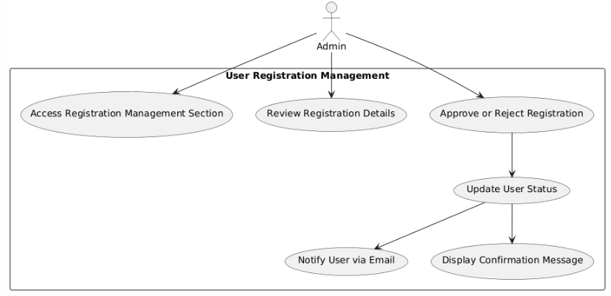

Figure 13 Use case Diagram user registration management

## 3.14 Inventory management:

|  |  |
| --- | --- |
| Use Case ID | FR_14 |
| Use Case Name | Inventory management |
| Description | Enables admins to monitor stock levels, update inventory, and manage low stock alerts. |
| Primary Actor | Admin |
| Secondary Actor | None |
| Input | Product ID, Stock quantity |
| Output | Updated inventory levels, Low stock alerts |
| Basic Flow | Admin navigates to the inventory management section.Admin enters or updates stock quantities for products.System updates the inventory levels in the database.System generates low stock alerts for products below threshold levels.Display confirmation message to the admin |

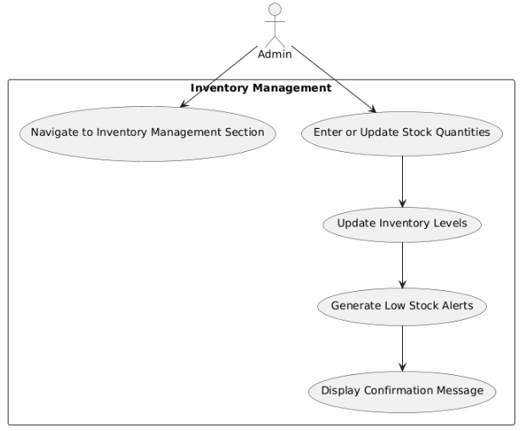

Figure 14 Use case Diagram inventory management

## 3.15 Order processing:

|  |  |
| --- | --- |
| Use Case ID | FR_15 |
| Use Case Name | Order processing |
| Description | Allows admins to view, process, update order statuses (pending, shipped, delivered, etc.), and provide tracking information to customers |
| Primary Actor | Admin |
| Secondary Actor | Customer |
| Input | Order ID, Updated Status, Tracking Number |
| Output | Updated order status,, Confirmation message |
| Basic Flow | Admin accesses the order management section. Admin selects and views an order. Admin updates the order status and enters tracking number.  System saves the updates and shows a confirmation message. Customer views order status and tracking information. ­System provides real-time tracking updates. |

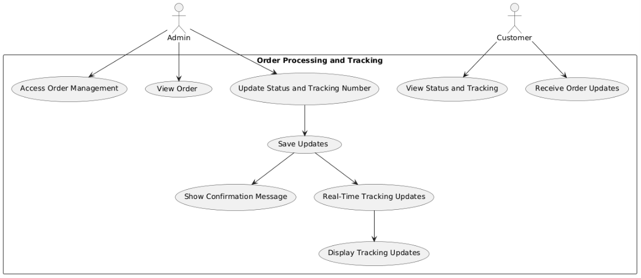

Figure 15 Use case Diagram order processing

## 3.16 Refund Processing:

|  |  |
| --- | --- |
| Use Case ID | FR_16 |
| Use Case Name | Refund Processing |
| Description | Allows admins to handle and process refund requests submitted by customers. |
| Primary Actor | Admin |
| Secondary Actor | Customer |
| Input | Refund Request ID, Refund Amount |
| Output | Confirmation of refund processing |
| Basic Flow | Customers submit refund requests through their accounts. Admins review these requests in the refund management section, then approve or reject them. If approved, the admin processes the refund via the payment gateway, and the system updates the transaction and order status. Confirmation messages are displayed to both the customer and the admin. |

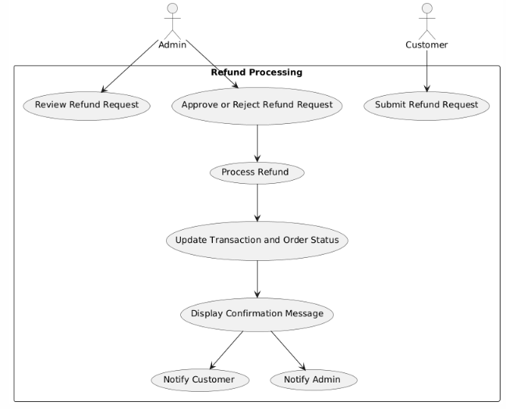

Figure 16 Use case Diagram refund processing

## 3.17 User authentication:

|  |  |
| --- | --- |
| Use Case ID | FR_17 |
| Use Case Name | User authentication |
| Description | Implements strong authentication mechanisms, including two-factor authentication (2FA), to ensure secure access to the Agri Shop web application. |
| Input | User credentials (username, password), 2FA code |
| Output | Access granted or denied messageg |
| Basic Flow | Users log in with their username and password. If correct, they enter a 2FA code sent to their device. The system verifies the code and grants access if it's correct, otherwise, it shows an error message. |

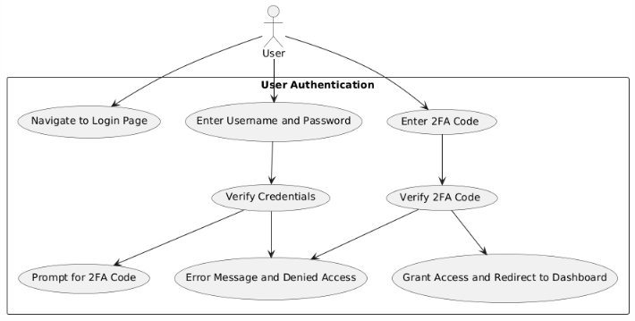

Figure 17 Use case Diagram user authentication

## 3.18 Discounts and Coupons:

|  |  |
| --- | --- |
| **Use Case ID** | FR_18 |
| **Use Case Name** | Discounts and Coupons |
| **Description** | Allows admins to handle and process refund requests submitted by customers. |
| **Primary Actor** | Admin |
| **Secondary Actor** | Customer |
| **Input** | Discount code details (code, percentage or amount off, expiration date, usage limits) |
| **Output** | Confirmation of discount code creation or update |
| **Basic Flow** | Admin navigates to the marketing and promotions section. Admin selects the option to add or edit a discount code. Admin enters discount code details including code, percentage or amount off, expiration date, and usage limits. Admin saves the discount code configuration. System updates the discount codes in the database. Display confirmation message to the admin. Customers can enter discount codes during checkout to receive the specified discount |

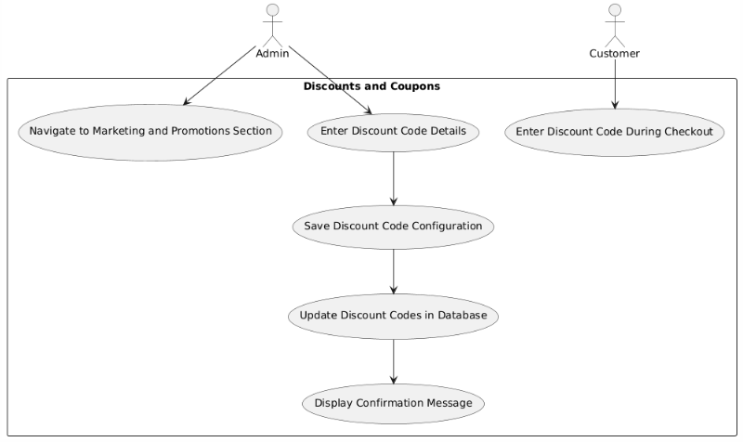

Figure 18 Use case Diagram discount and coupons

## 3.19 Customer support:

|  |  |
| --- | --- |
| **Use Case ID** | FR_19 |
| **Use Case Name** | Customer support |
| **Description** | Provides tools for managing customer support tickets and inquiries, as well as creating and managing a knowledge base and FAQs to assist customers. |
| **Primary Actor** | Admin |
| **Secondary Actor** | Customer |
| **Input** | Support ticket details (customer name, issue description), FAQ details (question, answer) |
| **Output** | Confirmation of ticket resolution or FAQ creation/update |
| **Basic Flow** | Customers submit support tickets or inquiries. Admins manage and respond to these tickets, updating their status and notifying customers of resolutions. Admins also add or update FAQs in the knowledge base. The system updates the knowledge base, and customers can access FAQs for self-service support. |

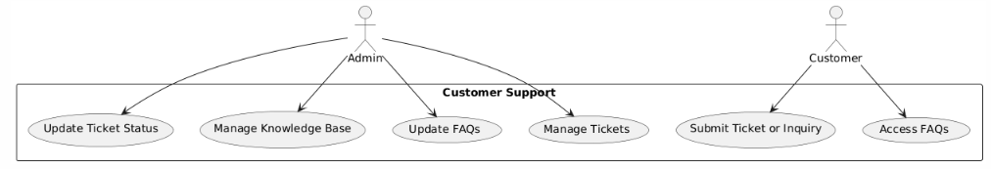

Figure 19 Use case Diagram customer support

# Chapter 4: Design

## 4.1 Architecture Diagram

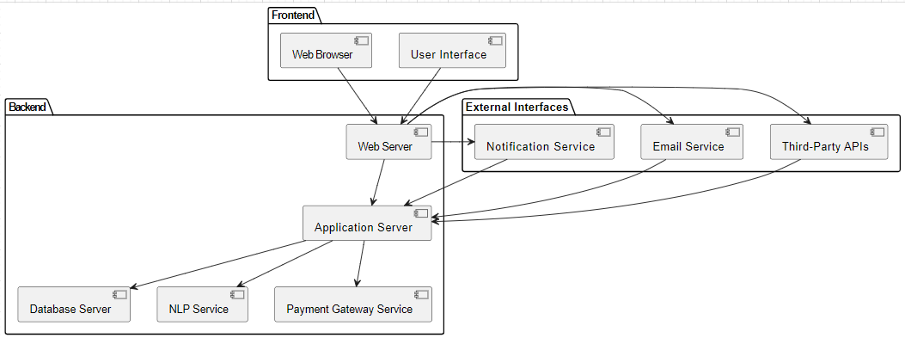

Figure 20 Architecture Diagram

## 4.2 ERD with data dictionary

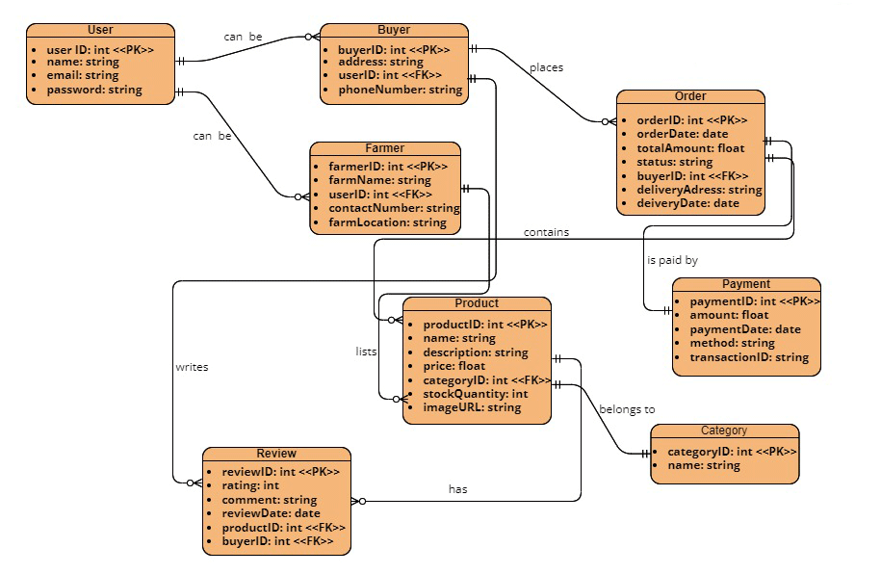

Figure 21 ERD

## 4.3 Data Flow diagram

Data flow diagram includes two levels

**The level 0**

The flow of information inside the system is defined in this level

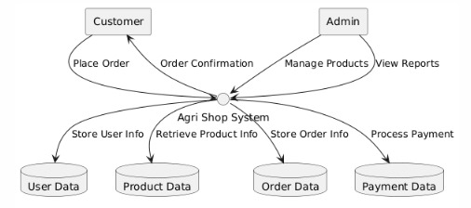

Figure 22 Level 0 Data Flow Diagram

**The level 1**

The flow of information outside the system is defined in this level

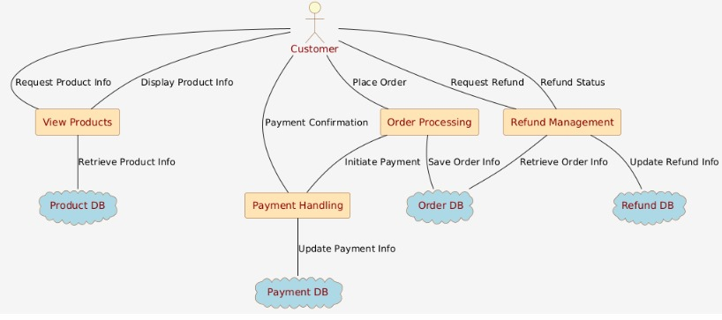

Figure 23 Level 1 Data Flow Diagram

## 4.4 Class Diagram

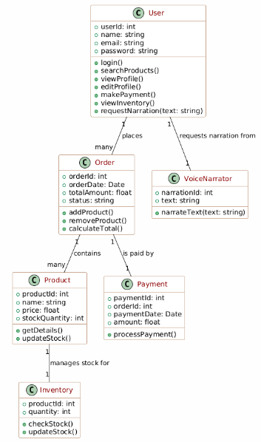

Figure 24 Class Diagram

Yaha farmer or consumer ki class add krni hai

## 4.5 Activity Diagram

**Activity diagram for create account**

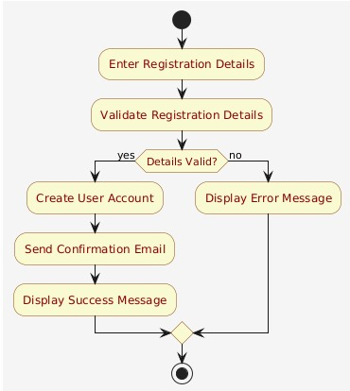

Figure 25 Activity Diagram Create Account

**Activity diagram for login account**

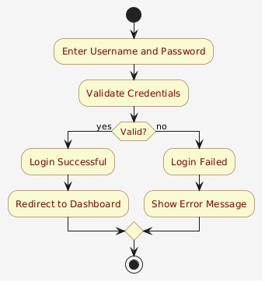

Figure 26 Activity Diagram login account

Yaha mujsy phch lena kiya krna hai …, aesy ni smjha pao ga

**Activity diagram for edit profile:**

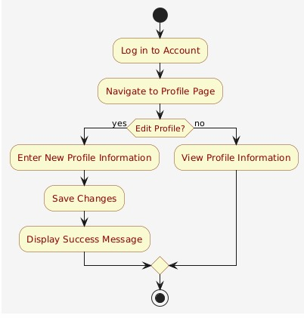

Figure 27 Activity Diagram Edit Profile

**Activity diagram for customer details**

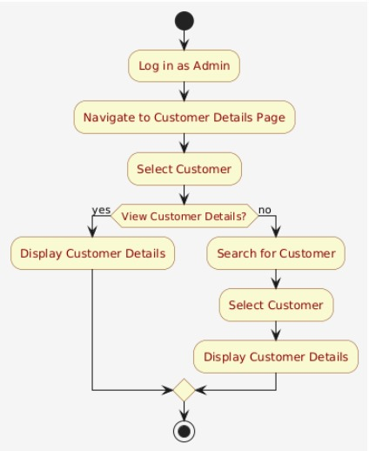

Figure 28 Activity Diagram customer details

**Activity diagram for search product**

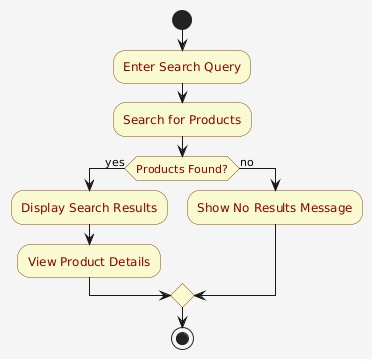

Figure 29 Activity Diagram Search product

**Activity diagram for Text to Speech:**

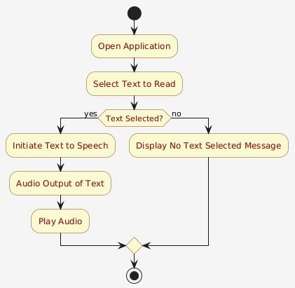

Figure 30 Activity Diagram text to speech

**Activity diagram for Text to Speech**

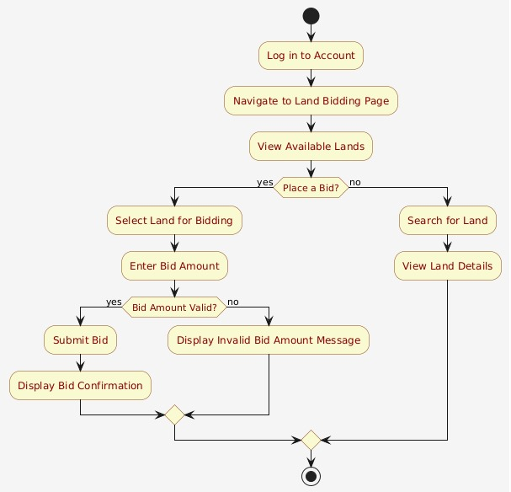

Figure 31 Activity Diagram Bidding account

**Activity diagram for inventory**

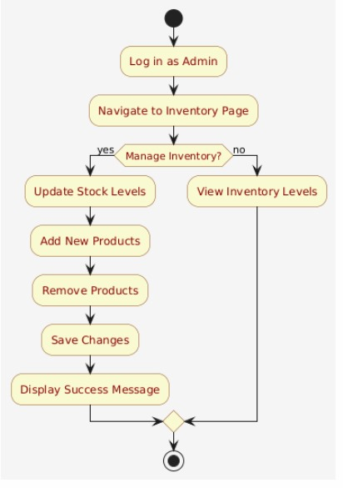

Figure 32 Activity Diagram Inventory

**Activity diagram for payment gateway**

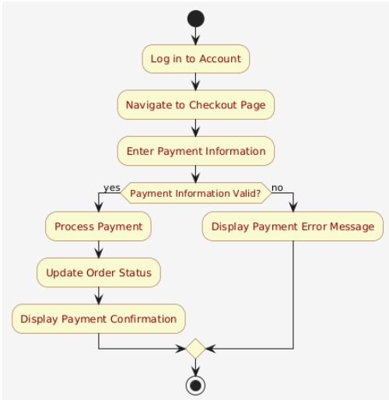:

Figure 33 Activity Diagram payment gateway

## 4.6 Sequence Diagram

This diagram includes the Sequence diagrams of the functional requirements of project along with the aggregated Sequence diagram

**Sequence diagram for create account**

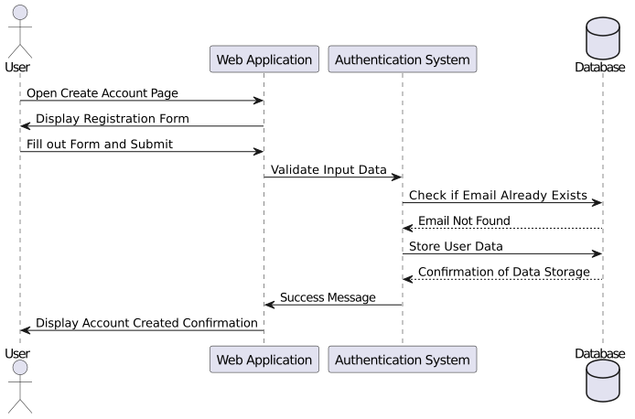

Figure 34 Sequence Diagram Create Account

**Sequence diagram for login Account:**

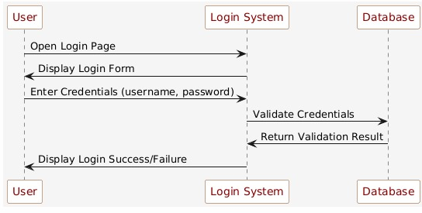

Figure 35 Sequence Diagram Login Accoun

**Sequence diagram for search product:**

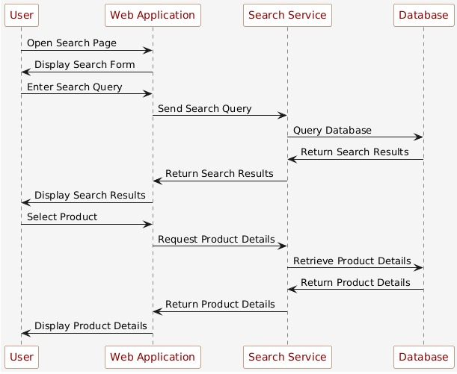

Figure 36 Sequence Diagram Search product

**Sequence diagram for Inventory management:**

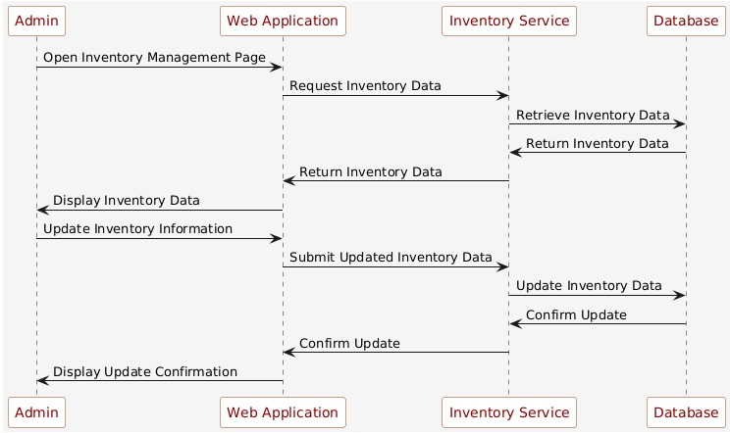

Figure 37 Sequence Diagram Inventory management

**Sequence diagram for customer details:**

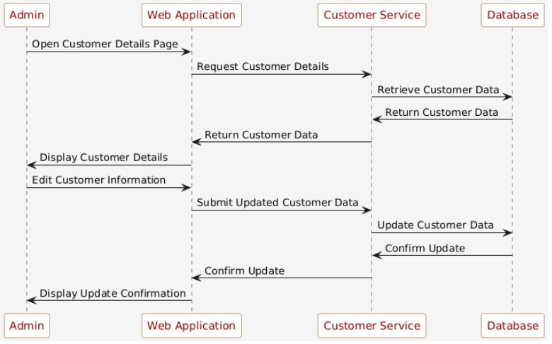

Figure 38 Sequence Diagram Customer details

**Sequence diagram for payment gateway:**

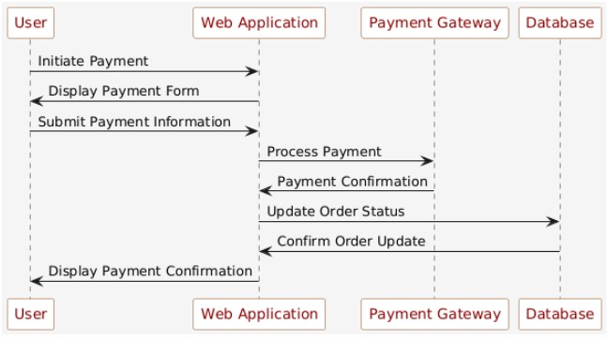

Figure 39 Sequence Diagram payment gateway

**Sequence diagram for Bidding System:**

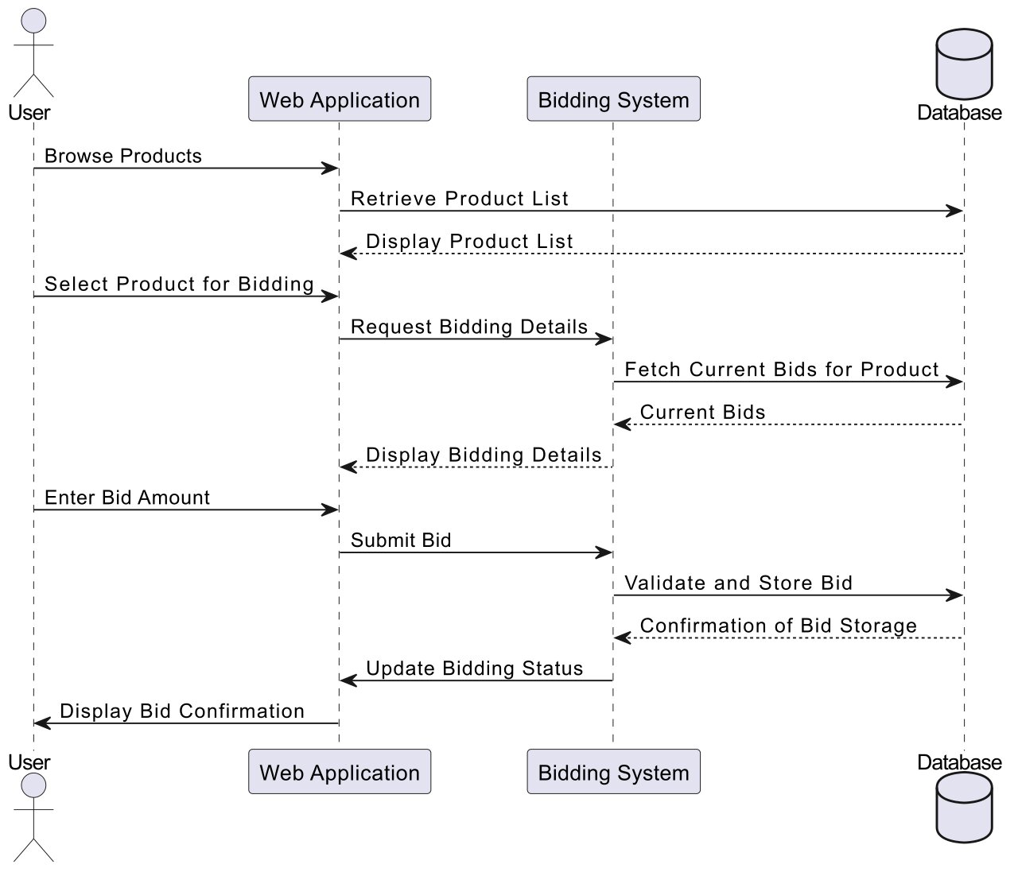

Figure 40 Sequence Diagram Bidding system

Yaha aik arrow add karna hai .,,, jesy mene lagaya hai ismy aik blue wala

**Sequence diagram for Text to speech:**

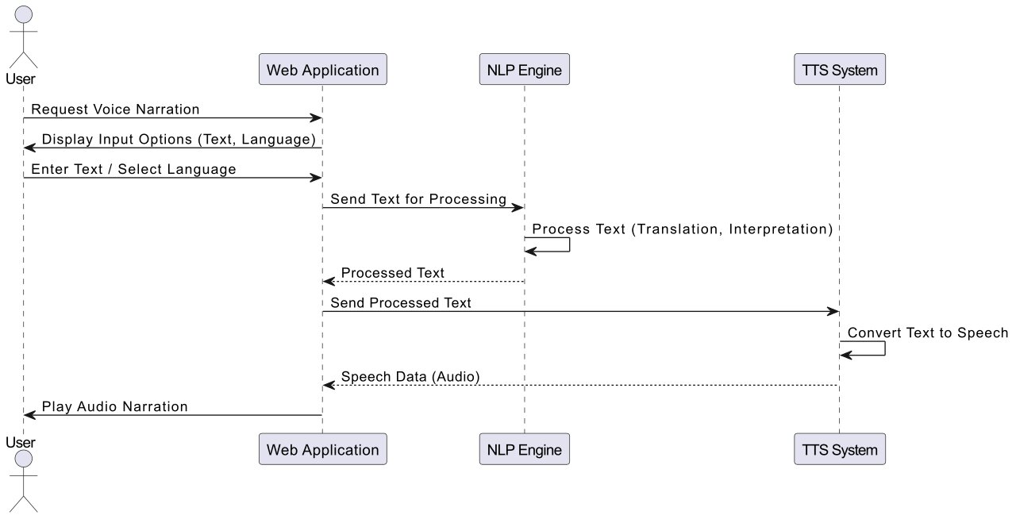

Figure 41 Sequence Diagram Text to Speech

**Aggregated Sequence Diagram:**

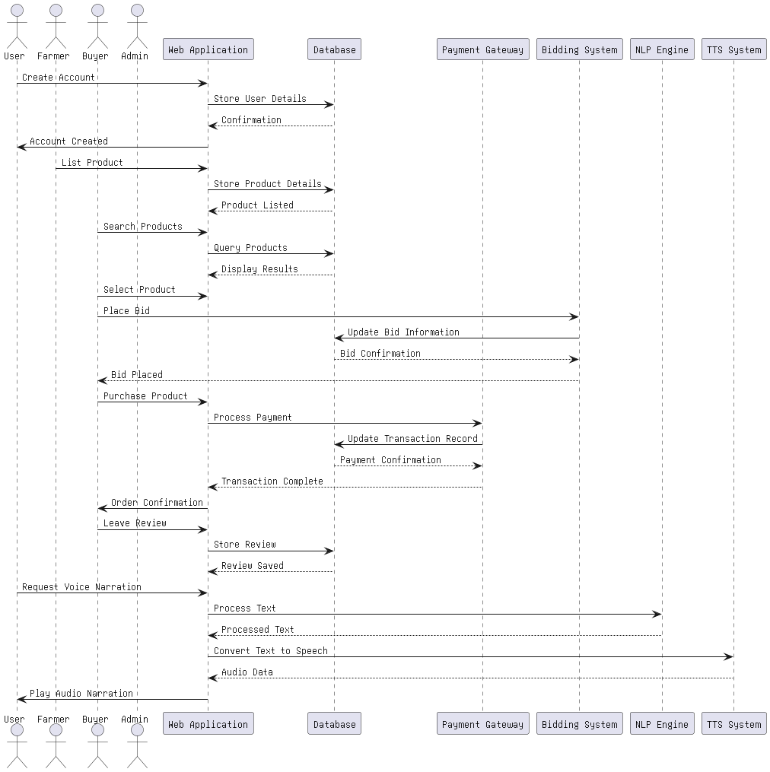

Figure 42 Aggregated Sequence Diagram

Ye bhi meeting me btao ga

## 4.7 Collaboration Diagram

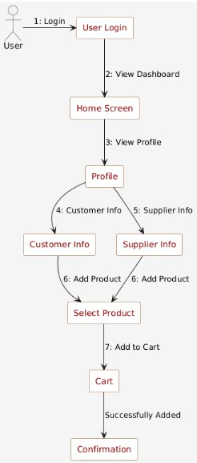

Figure 43 Collaboration Diagram

## 4.8 State Transition Diagram

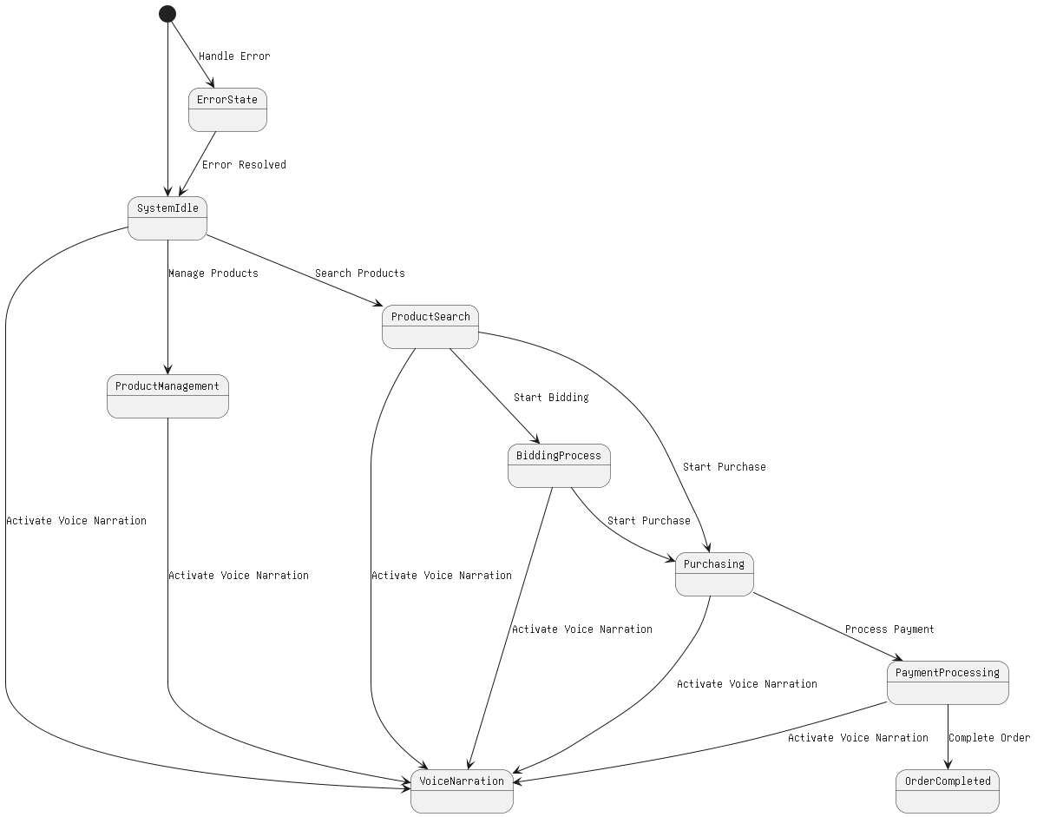

Figure 44 State Transition Diagram

## 4.9 Component Diagram

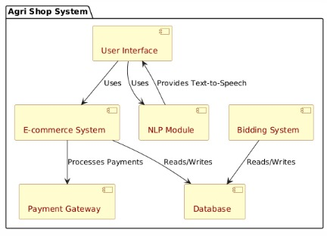

Figure 45 Component Diagram

## 4.10 Deployment Diagram

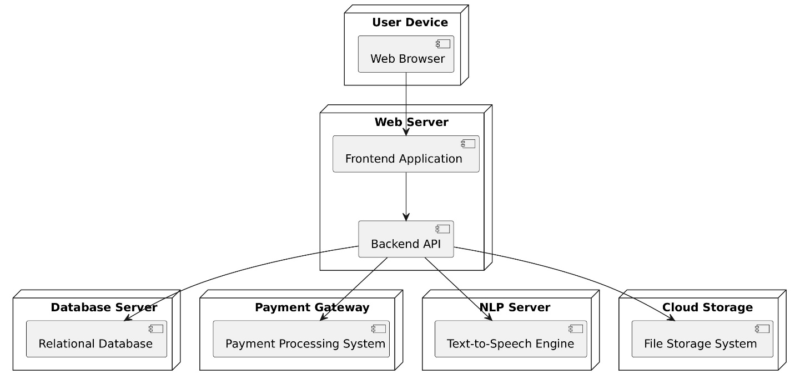

Figure 46 Deployment Diagram

# Chapter 5: User Manual

## Signup Page



Figure Signup Page

## Login Page



Figure Login page

## Home Page

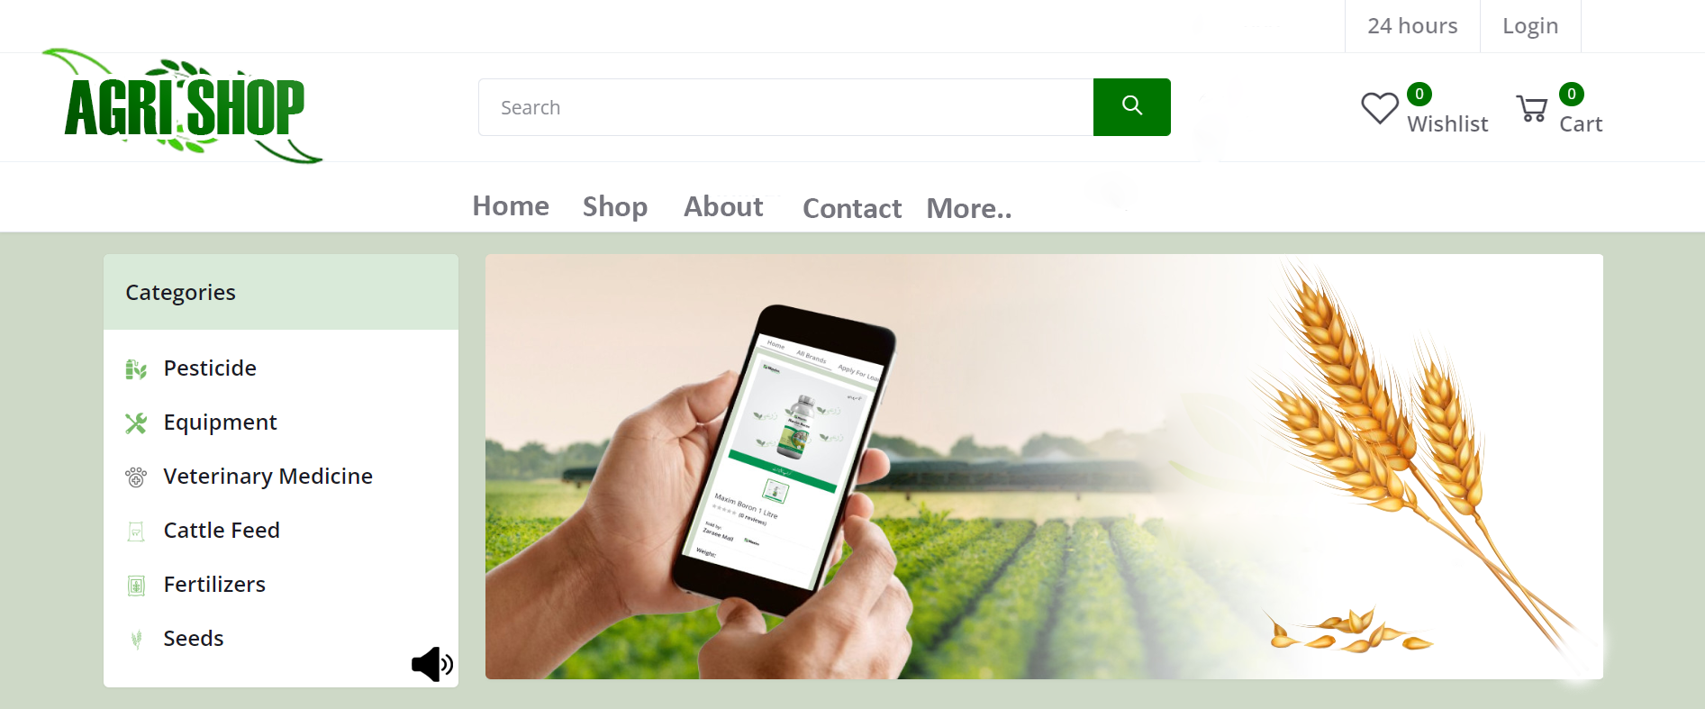Figure Home page

## Product Listing

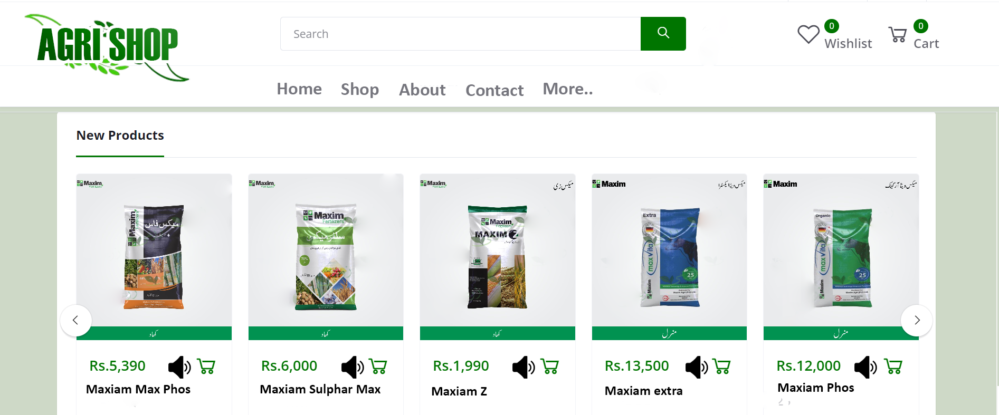

Figure Product listing

## Product Page:

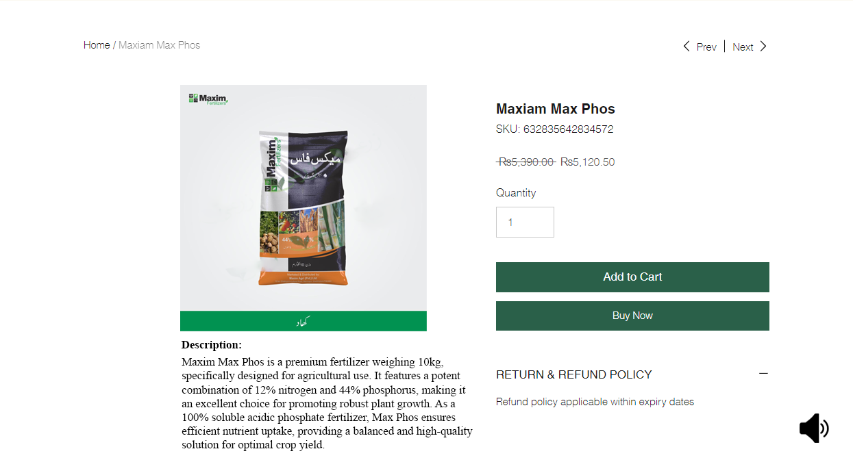

Figure Product page

## Footer:

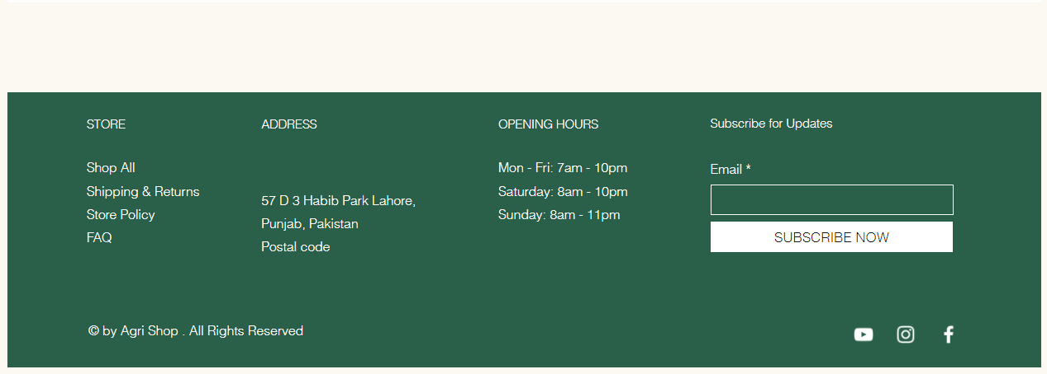

Figure footer

# References

# 

**Book**

1. Tom Hoobyar, NLP: The Essential Guide to Neuro-Linguistic Programming, California: Meta Publications, 2013.

**Websites**

[2] Harvard business review. (2022, april. 19). The Power of Natural Language Processing. Available https://hbr.org/2022/04/the-power-of-natural-language-processing